Project 1: computing all kinematic informations of a real manipulator

Name: Puda Zhao

StudentID: N13625214

netID: pz2078

Question 1: basics

Solutions:

To write down all these requested functions, we need formulas below:

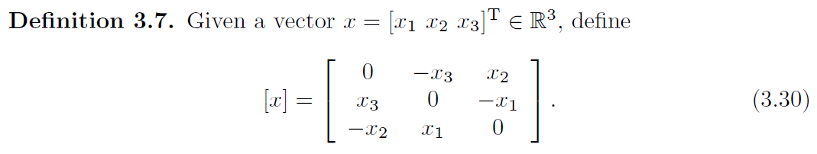

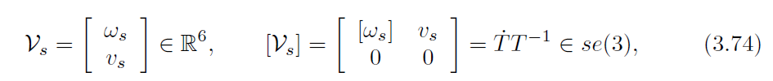

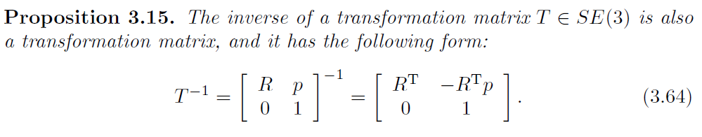

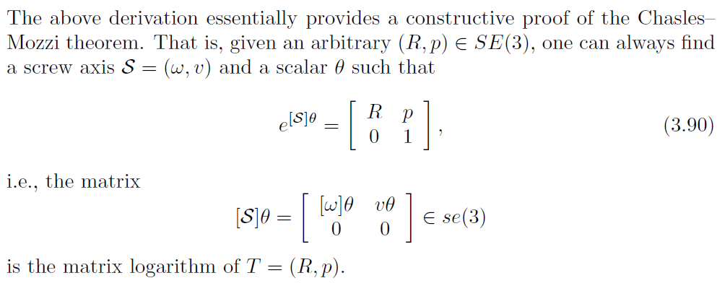

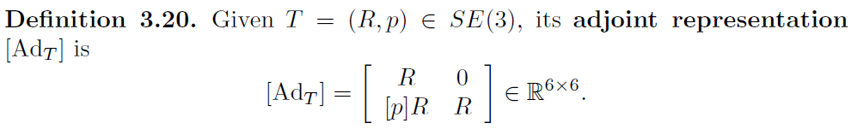

All the required functions have been posted in codes.

Question 2: forward kinematics

Here is the formula I use to write down the function:

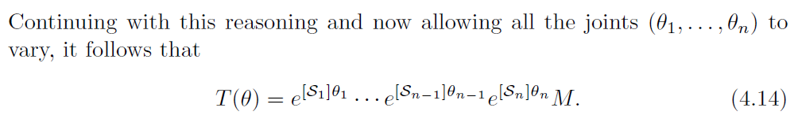

the required function has been posted in codes.

Question 3: Jacobians

Here is the formula I use to write down the function:

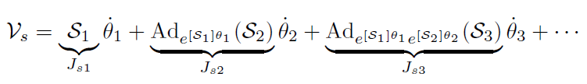

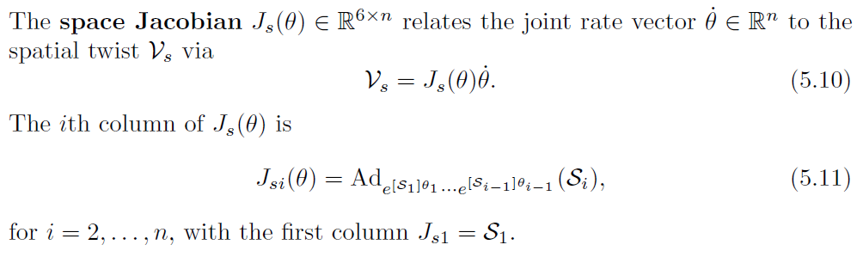

the required function has been posted in codes.

A note about Hint Q2&Q3:

I have posted some functions written when doing homework in the coding file. Here I will explain some examples How the function is written and how to use them:

(Normally, every extra function has a note in the coding file.)

**1. From w, p → Twist**

Usually we face a problem that we have to write down Twists(S) of joints from the given structure. Normally, it is easy for people to read w and p from a rotation joint. Then you have to use v = - w × p to get linear velocity. So I wrote a function that uses w and p as parameters to get the Twist corresponding to the joint

Function name: getTwistfromwp(w,p)

**2. Body Jacobian**

There is the following transformation relationship between Spatial Jacobian and Body Jacobian:

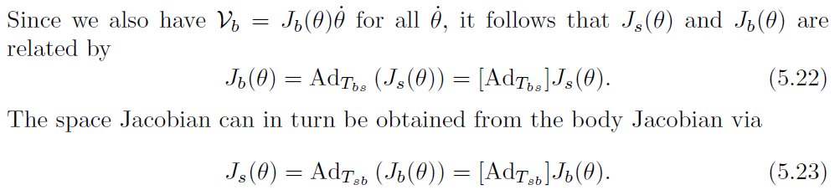

So the task is to write down a function that uses Jspace and FK(theta=0) as parameters to get Body Jacobian.

Function name: getJbody(theta,M)

Question 4: displaying hand trajectories

Hand trajectory: a trajectory similar to simple harmonic motion

Here are all the plots of x-y, x-z, y-z:

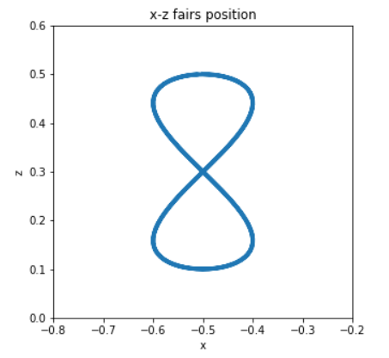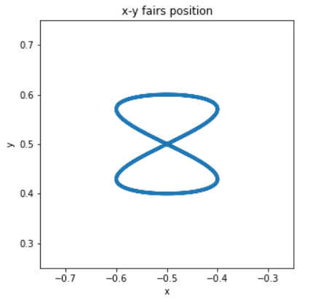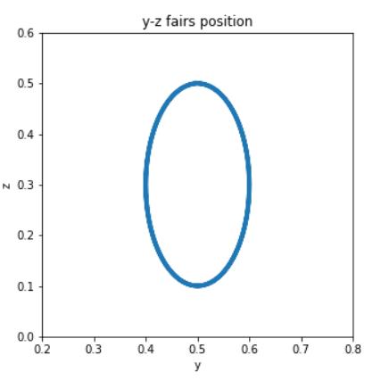

Question 5: computing velocities

Here are all the plots:

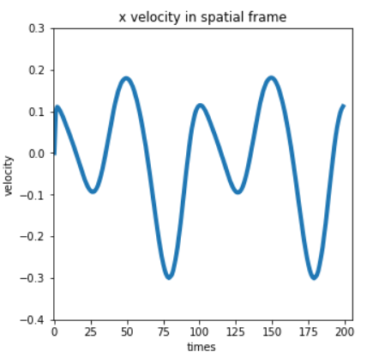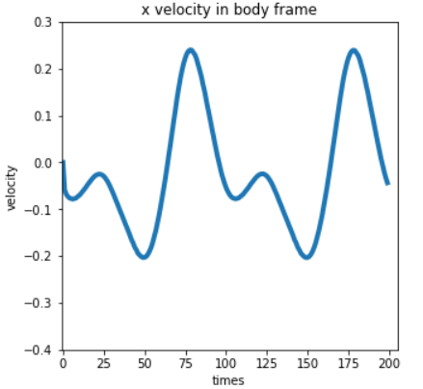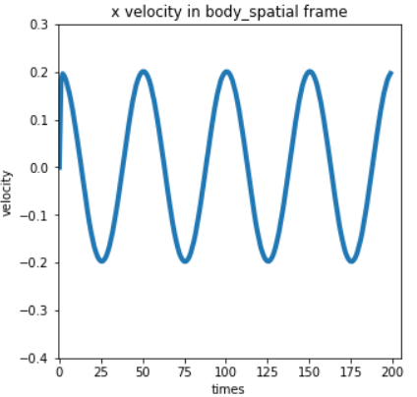

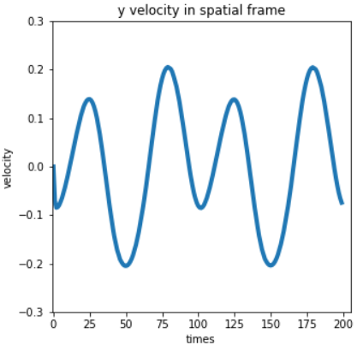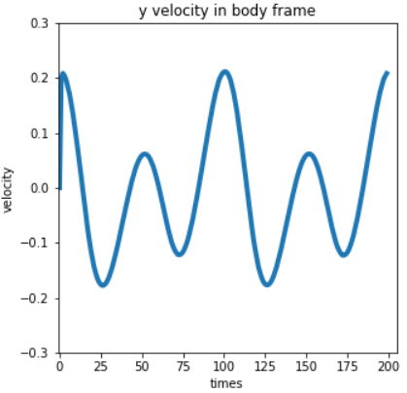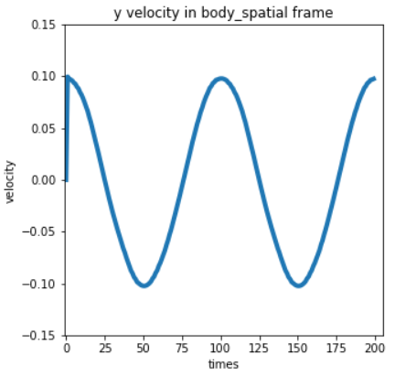

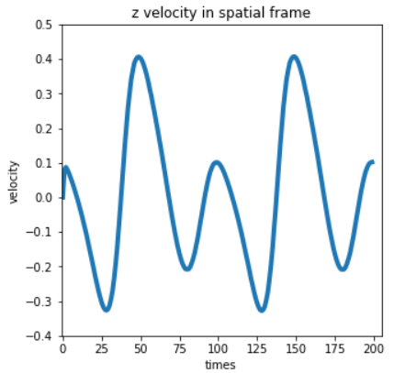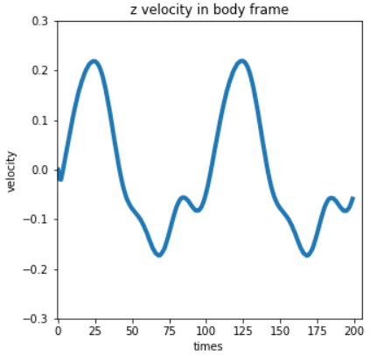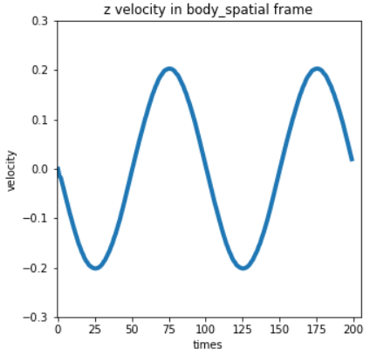

Notes:

Obviously, the plots in the third kind frame is the most intuitive. This is a standard simple harmonic motion, which fits more closely with the corresponding position image.